Has Technology Made the World a Bigger or Smaller Place Between the Years 1990 - 2010?

George Harrison#1, Gayathri Thiruchchelvam #2, Darren Wetherell #3, Jack Hedley #4

# De MontFort University  
The Gateway, Leicester, LE1 9BH

1 [p13215813@myemail.dmu.ac.uk](mailto:p13215813@myemail.dmu.ac.uk)

2 [p13236137@myemail.dmu.ac.uk](mailto:p13236137@myemail.dmu.ac.uk)

3 [p13205774@myemail.dmu.ac.uk](mailto:p13205774@myemail.dmu.ac.uk)

4 [p13216012@myemail.dmu.ac.uk](mailto:p13216012@myemail.dmu.ac.uk)

Abstract— In this paper we aim to answer the question ‘Has technology made the world a bigger or smaller place between the years 1990 - 2010?’ We wanted to investigate how technology was affecting society’s perception of the size of the world, and the reasons why it has changed so much within the stated time frame.

To answer this question we carried out quantitative research through questionnaires and qualitative research by using journals and other sources to examine and find and answer to the question.

Our results show that technology affects the respondent’s everyday lives with 17 out of 30 people using some form of technology within every hour. This along with the many academic journals and other studies show how the advancement in technology since 1990 has affected both how much we use technology; and how it has made the world a smaller place.

As our results point towards the world being perceived as smaller, it raises questions as to how much technology is affecting our social behaviour and our interaction with others or lack thereof.

1. Introduction

Technology has developed into many forms of physical mediums such as mobile phones, personal computers, tablets and even driverless cars. Software development of technology has also given us e-mail, search engines, VPN (Virtual Private Network), Video-on-Demand, online shopping and 4G.

These have presented to be beneficial for the society in terms of; interacting socially using social networks, shopping without hassle online, faster and accurate searches, watching videos whenever convenient and 4G for faster and better connectivity. Combination of those mentioned above makes the world a bigger place by staying connected each hour by the day, therefore we are more aware of our surroundings than ever before. But staying connected and having such services on demand can mean that the world is smaller than perceived because there’s no physical or mental effort in gaining such freedom of services in an instant.

The media has always perceived the invention, introduction and evolution of the internet as a detrimental change in society, in which we would all lose our abilities to socialise and think independently, thus making the world seem a smaller place. But in consideration to availability of vast amount of information on the internet means the world is bigger and very open than ever.

Therefore we conducted a research in the usage of technologies and as a result investigate further within considering the positives and negatives of having such technology available at this time of the 21st century.

1. Method

We chose to research the question of *has technology made the world a bigger or smaller place between the years 1990 and 2010?* Because we believed that as technology has advanced so has the size of the planet in terms of communication and technology as a whole, for example, people from Australia can now communicate with someone in America or the UK within seconds rather than previously hours, days or weeks.

Our intended approach to researching the question was both qualitative and quantitative. We decided to research into previous journals, books and websites on the different topics of Email, Search Engines, Virtual Private Networks (VPN), Video on demand (VOD), 4G, Social networks (Facebook, Twitter etc…), Online shopping and the Internet as a whole.

In our attempts to answer the question, we used the internet and the library at the university to find different journals, books and websites. We then researched these many different journals, books and websites, in an attempt to gather information and relevant data for our research.

We also created a questionnaire to ask 30 recipients around the university campus some questions about the usage of the points stated previously.

We handed the questionnaires to 30 random members of the university and asked them to answer the questions asked. We also told the respondents that all information would be collected anonymously for the security of the recipients. We then analysed all of our results both our Qualitative journals, books and websites to answer our question. We also used the Quantitative questionnaire to assist with answering and justifying the results that we found.

We then analysed the results obtained from the questions asked through the questionnaire and also the information obtained from the different journals, books and websites. This allowed the group to formulate an answer to our question by reviewing and assessing previous hypothesis and the different journals and other information on this topic.

1. FINDINGS

In the following section the findings of our study are presented. We provide an in-depth analysis of our results and later provide a discussion into how each piece of technology is affecting society. We use a variety of graphs and tables to summarize and reinforce our research.

1. *E-Mail:*

Since the inception of the email service in 1990, email has grown in its capability and function, it is now considered a vital communication medium which connects users and business 24/7 all across the globe.

The large number of e-mail clients available to users provides a healthy completion between the providers to ensure a quality and safe service. E-mail clients like Microsoft Outlook and Thunderbird are installed onto a user’s system and any emails that are received are installed onto the hard drive. This provides a security issue as Sullivan [1] explains; “… Vulnerabilities into email clients have been exploited by viruses, worms and other forms of malware.” The other problem with an email client is it can’t be accessed on every computer. Therefore “the majority of email users are switching from the conventional email clients to webmail for convenience.” Toney [2]

The transition from old email clients on a desktop to a more modern approach of webmail is making the world a smaller place as it allows someone anywhere in the world, with an internet connection, to access their email account and communicate.

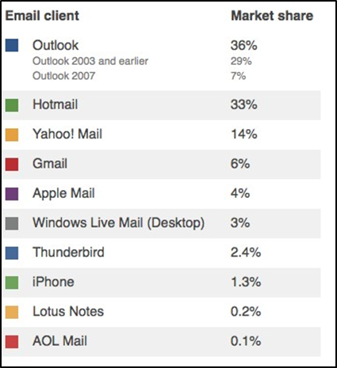

Table-1 [3]

Table-1 presents data that shows the market share of various e-mail clients used by businesses worldwide. The leader is Microsoft’s proprietary software, Outlook. This client has 36% market share. This is hardly surprising due to the fact that windows operating system dominates global market with roughly 90% share. Second is Hotmail, a web based email client with a 33% share on the market, Hotmail has over double the share against its next rival Yahoo Mail. Gmail, Apple mail and windows live email clients all struggle to achieve a share in the double figures.

The figures in table-1 back up Toney’s claim that web-mail is becoming more widespread, Hotmail is not far behind Outlook. The next e-mail client for desktop is Windows Live Mail with only 3%, just in front of Thunderbird at 2.4%.

Email makes the world a smaller place by its successful marketing usage. Pingdom.com [4] reports that there were 2.9 billion active email accounts worldwide in 2010. The sheer number of email accounts allows businesses to market their services on a huge scale. “Businesses can now create the perception of being much larger and more prestigious than they actually are.” Toriangroup.com [5] A solid, professional looking email, coupled with an inviting website makes the person think they are a big money organisation, thus enquiring about the companies services.

The fact that e-mail is free and it costs nothing to send an e-mail is hugely beneficial to companies for marketing purposes.



Table-2 [6]

Table-2 shows the percentage in which e-mail was used for marketing purposes by businesses in 2007.

Cragg [7] states that “changing technologies such as the internet, email and video conferencing continue to make the world a smaller place where communication anywhere around the world is almost instantaneous.”

Aside from the marketing use of email, email is used to connect people and businesses worldwide. People can contact friends and family who live abroad and get a response within five minutes. Compare this to sending a conventional letter by post, there would be no guarantee that the letter arrived and it would take weeks to get a response.

From the results of the questionnaire carried out, we can see that email is most often used within every hour. Nowadays people synchronize their email accounts with their phone so as soon as an email is sent to their account it is pushed onto their phone. We can see from the results that the world has become a smaller place because email is so accessible, people can connect with other people and businesses wherever they are and immediately send a response.

1. *Search Engines:*

“Using a search engine to find information is often listed as one of the most common tasks performed on the internet.” Paltoglou et al [8]

Search engines over the years have grown in popularity and are used every day by people who need to find information or websites.

Search engines have made the world a smaller place by connecting people with businesses worldwide. Whether it be someone searching for the cheapest plane ticket or someone searching for a company that sells their favourite pair of shoes.

Out of the 30 participants in our questionnaire, most people said that they use a search engine within every few hours. A search engine is a popular feature of the internet, however it is not needed to access every website. As I mentioned earlier it makes the world a smaller place because it gives people the opportunity to look in more than one shop for a item that they want.

Search engines have made it possible for businesses big and small to be found by a global audience, thus improving the company’s yearly revenue. As Encell, Dunn [9] explains: “The smallest home-based businesses now can reach into the global marketplace at practically no expense at all. You can sell almost anything if you can get the word out…”

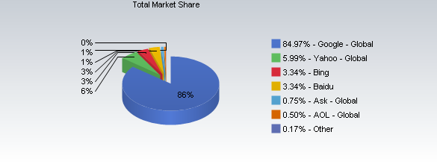

Graph-1 [10]

Graph-1 shows the market share of the most commonly used search engines. As expected Google has the outright, lion’s share, of the market at a staggering 84.97%. Yahoo has the second largest market share way down at only 5.99%. In third is Microsoft’s relatively new search engine, Bing, with a share of 3.34%.

Google is well known for its search engine and has been since the late 90’s. However Google is now known for much more than just its search engine, it provides services like Google maps, Gmail, chrome web browser and it owns the successful YouTube website. All of these services are being used by millions every day, with the Google brand being advertised worldwide to both businesses and people.

Most of Google’s services are free, such as Gmail and the chrome web browser. Google gets all of its money from advertising. Kiss [11] reports that “97% of revenue is generated by advertising”. Google has an Adwords service where website owners can sign up for free and for every visit to their site from one of Google’s sponsored ad’s, they pay Google as much as $50 per click.

The pay per click model prices range up or down depending on the keyword. Kiss [11] reports that insurance, loans and mortgages are among the top three keywords that are the most expensive.

The Adwords service could cost a company who participates a large amount of money each month, because the person who visits their site might not buy anything, yet the company still has to pay Google a sum of money. However despite the cost, Adwords from Google is making the world a smaller place because it’s putting companies on the first page of search results and vastly increasing the chance a person will visit their site. That person might purchase from the site, they might not, but it’s Google that has put that company onto the screens of its global users.

1. *Virtual Private Networks (VPN’s):*

Virtual private networks made their first appearance in the mid 1990’s with Microsoft creating the first iteration of VPN software. Eaton [12] This advancement in technology has led to the creation of many different VPN providers that are all available for everyone to use.

Figure 1, below, shows the worldwide market share of virtual private networks with Juniper having the most at 31.4%. They have a much larger majority than their rivals Citrix (18.7%) and Cisco (17.2%). The next largest VPN providers are Checkpoint and F5, with the rest of the market share (12.9%) belonging to other smaller providers.

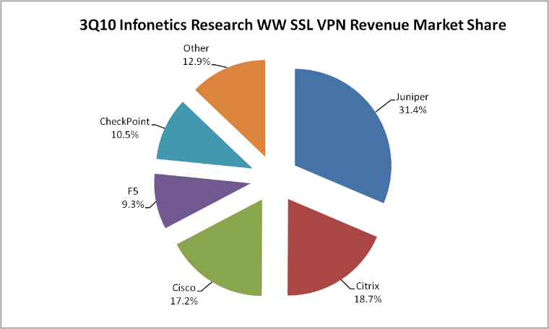

Figure-1 [13]

Virtual private networks are being used more frequently as they allow users to connect securely to remote networks all across the globe. The ability to connect to networks from anywhere in the world is making the world a smaller place with many major corporations utilising their services. Cisco [14]

Many universities have adopted the use of VPNs so that their students and staff can access resources when they are off campus. However the questionnaire given to 30 students on the De Montfort campus shows that the usage of virtual private networks is relatively limited; with 22 of the 30 people asked, not using VPN technology at all.

The reasons for university students’ not using VPN’s may be that it is not required for their course as their subject of study doesn’t involve the need to connect to a remote server.

However some students may use VPNs for entertainment purposes to watch American media content that may be blocked in the UK. Schofield [15]. The importance of VPNs is shown as major VOD provider ‘Netflix’ has also stated that they will not ban the use of VPNs as there are too many people that use them. Fletcher [16]

The use of VPNs makes the world a smaller place as people no longer need to travel and are able to view censored material from other countries. Being able to view said media can connect people across the world when it was previously impossible to do so without the use of VPNs.

1. *Video on Demand (VOD):*

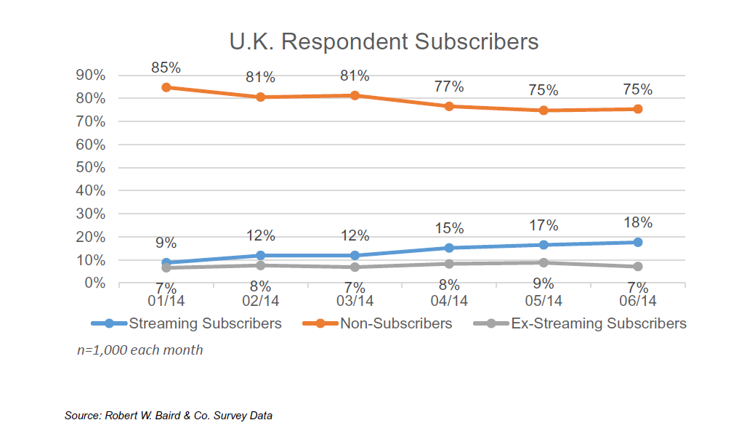

Figure-2 [17]

Figure 2 shows the amount of subscribers for the popular streaming service ‘Netflix in the UK. Shukla [17] The graph shows that there has been a steady increase in streaming subscribers from 9% to 18%. Indicating that that 18% of all broadband connected homes are subscribed to Netflix. This equates to around 4.5 million subscribers within the UK.

This growth of video on demand is due to the expansion of content being made available from services such as Netflix, BBC iPlayer, and YouTube which have grown at a rapid pace over recent years with “over one in four (26%)” people spending more time watching video on demand than watching traditional TV. Webcredible [18]

This growth is expected as people will often take the more convenient way of accessing media. Thus leading to the assumption that technology is making the world a smaller place due to the fact that vast amounts of content is viewable easily from the comfort of the users own home.

The questionnaire given to students’ also shows that video on demand is very popular and enforces the fact that technology is making the world seem a smaller place. 4 people claimed to use it every day whilst 17 people use it at least once a week. The popularity of VODs at university is expected for many reasons such as the fact that university students can have a large amount of spare time available to them and as a result less people are going to cinema, Hudson [19], or watching TV with friends.

This anti-social behaviour coupled with the fact that VPNs can be used to access geographically blocked content, Bogle [20]; results in making the world a smaller place as people can use services even though they are in an entirely different country.

1. *4G:*

After the introduction of 4G technology around 2007, billions of people all over the world have benefited from the increased speed it brought. This also led to the growth of mobile usage which increased dramatically over the past two decades as shown by Chopra [21].  
  
 4G has removed physical distance as a hindrance on being able to work or to browse the internet/ stream media making the world seem smaller. It has also allowed us to communicate with people in different parts of the globe, making us perceive the world to be a smaller place.

Figure 3 shows the increased popularity of 4G and its usage in the UK compared to 3G. SmartlPX [22]

It shows that more people are using 4G for intensive activities such as streaming media with 29% of people streaming video more than once per week.

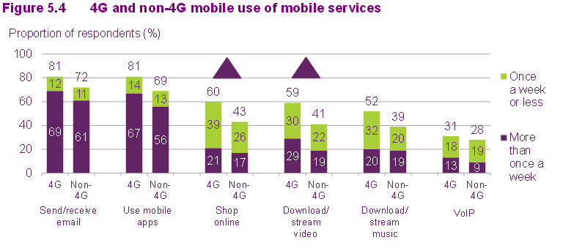

Figure-3 [22]

This popularity can also be seen from the campus questionnaire as it shows that people use 4G on a much regular basis with 12 people using it every hour, and 4 within every few hours. Furthermore with advancements made in mobile technology transmitting multimedia to each other is faster than using past technology, Fagbohun [23] , allowing for people to share pictures, videos and experiences with each other ultimately making the world a smaller place.

1. *Social Networks:*

From the research completed into different journals, books and websites the results we found have shown that the world has become smaller because of the use of social networks as stated by Carr [24] who described the world as becoming smaller due to the narrowing gap of information and knowledge. It was also found that communication across the world was increasing because of technology as stated by Sawyer [25] and that the world was becoming smaller because of increased advertisement of businesses and the increased range of there scope as seen from Yusuf [26].

We found the journals also said the world was becoming bigger in certain ways as seen by Porter [27] who expressed the view that people are becoming dependent on social networks.

The journals also showed that for less economically developed countries, the world was becoming bigger because they were becoming shut off from the world as stated by Tambulasi [28].

The journals also found that people have become dependent on communication through technology rather than face to face communication. Shelke [29]

Our research into online shopping through the journals, showed that the world has become smaller because of convenience of online shopping as said by Forsythe [30]. In addition the research shows online shopping has also allowed for those with disabilities to be able to shop more widely and effectively showing the world has become smaller, as seen from Stenitzer [31]. The journals have also shown that online shopping has allowed for worldwide purchasing as seen from the journal of Jiang [32].

We researched further into the differing journals we found that some were showing that the world had also become bigger as seen from Koyuncu [33] who said you now have to wait for the delivery of your items. Forsythe then stated the world has become bigger because of the long process of online returns. It has also been read that many have discussed that cash may start to become obsolete with the introduction online shopping and its payments as seen by Fung [34].

The creation of the first social network was in 1994 and this was the start of many changes to the world making it both smaller and bigger in different ways. This can be seen from the information published in the journals.

“Geopolitics and the ubiquity of social media have made the world a smaller and seemingly gorier place.” Carr [24]. “People across the globe can interact with each other within seconds of sending and receiving messages” Sawyer [25]. “Online we know exactly how many people have looked at a specific page, the contents, and how many have clicked on the advertisements.” Yusuf [26].

Carr, Sawyer and Yusuf all describe the world as becoming a smaller place through the use of social media because of three different views. Carr describes the world as becoming a smaller place, as, due to the use of social networks, the gap between the different countries and our knowledge as to what is happening in these countries is narrowing. This is because social networks have narrowed the gap of news and information that we receive. We are now more connected to the world. This connection allows for us to be more connected through news and communication on our social network feeds which in turn makes the world a smaller place.

Whereas Sawyer explains that the world has become smaller because we can now communicate between different continents using social networks in the matter of seconds where as previously it would take weeks or months to do this through such ways as letters. This shows two of the ways that the world really has shrunk in terms of technological size compared to previous years. Ever since the creation of social networks there has been a growing population of people joining social networks and using these to communicate with each other.

Yusuf goes on to describe that social networks have made the world smaller for businesses because it allows for the marketing of their products and also allows for them to monitor who has clicked on their advertisements. This gives businesses a host of further information on the profiles of the people viewing their advertisements. This in turn makes the world smaller because previously, when social networks didn’t exist, there were no adverts that would collect information. Now, when you click on an advert, it will then collect information on the customer or viewer so the company would be able to tailor their advertisement to their sales.

The journals we used also describe the world as becoming a bigger place because of social networks as described by Shelke [29] “They become so dependent on it that they start to think making contact with other people outside the social network is not necessary”, Tambulasi [28] “when ICT is brought into the picture, it tends to exacerbate social exclusion by reproducing existing social networks of inclusion and exclusion”. And Porter [27] “We are becoming increasingly dependent on social media”.

Shelke, Tambulasi and Porter all express the views that the world has become bigger with the use of social networks. Because of three differing ways we have all become dependent social networks.

LEDC’s or developing countries are becoming left behind or excluded because the use of social networks. Tambulasi goes onto express the views that world has become bigger through the exclusion of the many LEDC and developing countries in the world because of their limited ICT infrastructure and there limited use of social networks. This is making the world bigger because communication and interaction with these countries is being limited not always by choice but sometimes by the wealth of the country which in hand closes off parts of the world from communication making the world bigger.

Furthermore the questionnaire has allowed for analysing of further results on online shopping, it has shown the group the different usage of social networks. From the results we can see that social networks for majority are used at least every hour or every few hours, with a small percentage either not using social networks or only using it once a week. This can be seen from both angles that the world has become bigger because people are using them to socialise rather than face to face interaction or the world has become smaller because it has allowed for people to become more interconnected with each other.

Social networks are changing the way that people communicate rather than previously face to face communication we are now communicating through social networks. Shelke describes the way that people are now becoming dependent on using social networks to communicate, instead of face to face communication and interaction. This is making the world bigger because people are now using social network to communicate rather than meeting with friend or other to communicate.

With the increased use of social networks people are now shutting there selves away from others and face to face interactions. Porter explains that because people are now becoming dependent on the use of social networks it has made the world bigger because people are starting to shut there selves away from the real world and limiting there interaction with it through the increased use of social networks.

1. *Online Shopping:*

The introduction of World Wide Web in 1990, advanced significantly the use for online shopping even further that what was previously available. This can be said to have made the world both bigger and smaller.

Many have expressed the views that online shopping has made the world both bigger and smaller place. The world could be said to have become smaller from activities such as convenient shopping, as detailed by Forsythe [18], “the benefits provide the sorts of convenience that are not readily available in traditional shopping media.” People have also expressed the views that it has opened the doors for people with disabilities as described by Stenitzer [31], “Because of their limited mobility elderly and disabled people can benefit from online shopping to a great extent”.

It has also been said that it is easier to source and purchase products from all over the world, as described by Jiang [20], “International online shopping is no longer mostly engaged in by people looking for items that are hard to obtain in their domestic markets”.

All these three different journals all detail different views of how the world has become smaller with the introduction of online shopping. Forsythe explained that online shopping has allowed for convenient shopping making the world smaller because rather than having to go out shopping and looking for a certain product in a store, it can now normally be found using online shopping within the matter of a few minutes. This makes the world smaller because it now allows for the easy, faster and convenient shopping.

Stenitzer describes the world as becoming smaller because it has allowed for the integration of the elderly and disabled into a convenience online shopping market because prior to this those in a wheelchair or with crutches may have struggled with normal shopping even if the shop has been fitted for mobility purposes. Now online shopping has allowed this part of society to be able to access their goods with ease in their own home or on the go on a mobile device.

Jiang also describes that the world has become smaller because we can now access items from all over the world that we may not have previously been able to access and purchase. This has made the world smaller because instead of being stuck with the goods of the country in which we reside, we can order goods from other countries from all over the world.

Conversely however, it has also been described in many journals that online shopping has made the world become a bigger place. The waiting for the delivery of items, if there are any problems once the item has been received and with the increased use of online payment methods cash is becoming obsolete. As seen by Koyuncu [33] “delivery issues make negative contributions to an individual’s probability of purchasing from the Internet”, Fung [34] “retail payment may render cash Obsolete” and Forsythe [35] “difficulties in returning faulty merchandise”

Koyuncu describes that the world has become bigger because previously we could just go in a store and pick up the item there and then, whereas now with online shopping, we have to wait for the delivery of an item. This results in much longer lead times between purchase and receipt. It really shows how big the world is when you are waiting to receive an item from another country which can take weeks rather than just going down to your local store and making the purchase there and then.

Fung goes onto describe that with increased online payment with online shopping, cash is becoming redundant. This is because online shopping requires payment online and therefore cash sales are not possible, in turn making the world a bigger place.

Making cash redundant has promoted the use of credit and debit cards rather than as previously with the use of cash. This has in turn increased the geographic size of the overall retail market again making the world a bigger place.

Forsythe goes onto explain the way the world is becoming bigger because of the problems with returning online products where as previously we could just go into our local store to return a product now the customer has to go through a chain of different steps to return an item with a lot of time cost to themselves. Nowadays online stores use computer based software to allow for the returning of the item which again makes the world bigger because there is less human interaction and it is a much longer process to return a product to an online store than a normal one.

From the results of the questionnaire we can see that the majority of the 30 people we asked will normally only use online shopping once a week and 10 people saying that they do not use it at all. We analyse these result to that it has allowed for ease of shopping and allowing for products to be at our finger tips from a few clicks which in turn makes the world smaller. But it can also be seen from the results that the world has become bigger because we now have to wait and some people do not use the ease of only shopping and many only use it weekly.

1. *The Internet:*

Amalgamation of the internet and the WWW (World Wide Web) has become to what we now know as ‘The Internet’. Since the invention of the WWW by Sir Tim Berners-Lee on 12 March 1989, many updates and add-ons have been made to the WWW for the availability and compatibility of web pages, same is applicable for the Internet.

Functionality of the internet is through connecting to a network via other networks, while the WWW functions using URL (Uniform Resource Locator) by referencing to an address such as bbc.co.uk/news; the page referenced should be in HTML (HyperText Markup Language) or other similar. The internet functioned many years before the WWW, as a means of protocols such as SMTP (Small Mail Transfer Protocol), FTP (File Transfer Protocol) and etc.

Invention of the internet has had adverse effects on many aspects of day to day life. All technologies such as online shopping, 4G, E-mail and etc. has become only available with the rapid development of the infrastructure of the internet. While benefits of the internet may be evident, we have to consider the transformation of society of adapting to being connected consistently.

Economic benefit the internet has aided many countries in becoming technology powerhouses and organisations will continue to exploit the strengths and weaknesses of the internet to find gaps within the markets.

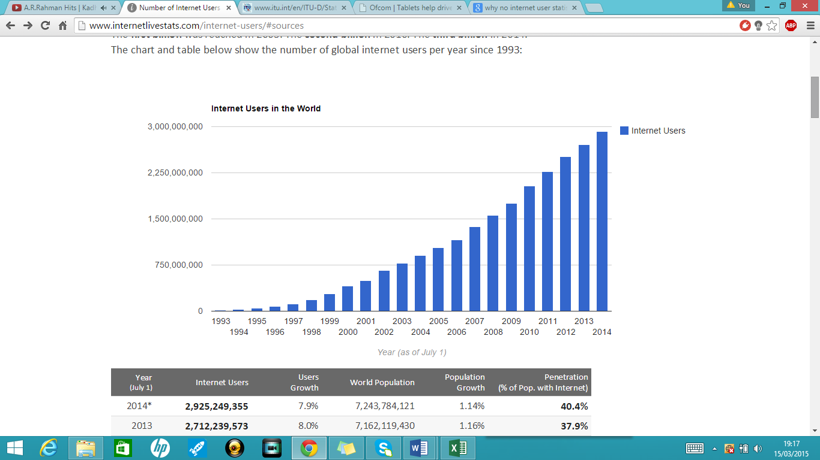

Figure 4 [36]

As of 2014 there are 3 billion active internet users worldwide, with developed countries having more than 78% of regular internet users as shown in figure 4 [37], this makes the world a bigger place previous to 1995; less than 1% of the world population had access and used the internet [38], this correlates positively to the students that were questioned as using a technology on any medium requires connecting to the internet.

Complications of technicality within technology resulted in less user friendly mediums from 1990. Also mediums which connected to other networks was considered only to be used by professionals with adequate knowledge on technical matters.

Recognition of GUI (Graphical User Interface) was a significant step in making technologies more appealing to individual’s e.g. Windows 3.0 [39]; using 3D icons that related to specific tasks meant all the program codes was hidden. The success of video-on-demand, e-mail, online shopping have been dependent on the strong use of GUI for example in online shopping; the user will have to view, make selections on size, review the order and enter bank details to make a successful online order, this reflects the results of the questionnaire as 20 individual’s out of 30 shopped once a week online.

With the growing popularity of personal computers from 1982 [39] meant connecting to the internet was through metres and metres of wire plugged into a socket; hopefully having success connecting to the local network e.g. within an institution. This resulted in the world being a smaller place because you would require the knowledge for the connection and program the personal computer with protocols for internet connection which was time-consuming and complex.

But the significance of the internet increased with the availability of Wi-Fi (Wireless Fidelity); initially used by America’s telecoms regulator, its standards published by 1997 and introduced by Apple through AirPort [40] , therefore resulted in the world becoming connected and bigger as a place as users can easily connect to other networks without the physical restraint such as wires.

The use of VPN (Virtual Private Network) was enabled by the use of Wi-Fi and therefore connecting to the internet and accessing documents was straightforward. The individual’s questioned in our survey; 1/3 used VPN at least once per week to access the Universities virtual learning lecture materials via the internet.

The rise in internet evolution means implication in society which will have negative and positive effects. Study carried out from 2002 to 2007 by Manuel Castells, ‘Internet does not isolate people, nor does it reduce their sociability; it actually increases sociability’[41], this shows that individuals can now express their views and opinions online without being restrained by the society and it’s a new form of autonomy. This reflects the use of internet to gain access to different social networking platforms such as Facebook and Twitter. Internet has now become a stage for political opinions, economical progress and development in technological mediums. Therefore, making the world a bigger place in the digital information era.

1. *Questionnaire:*

The questionnaire represents data collected from a survey of 30 students, carried out on university campus. The most frequent use of technology is accessing social networks. 17 people said they accessed a social networking site within every hour. This result was expected because social networking is available on a vast number of platforms like mobile devices and pc’s. E-mail and search engine usage wasn’t far behind, again this reflects the fact that these technologies are widely available, free of charge on a number of platforms. Search engines are mostly used within every few hours, people don’t need a search engine to get onto a known website. 14 people use the internet as a whole mostly every day, this could be that people are browsing websites to keep up to date with the news, weather or sports.

Video on demand and online shopping are, as expected, mostly used once a week. People will usually only do their weekly shop once a week and not 1 item every day. Also because of the cost involved in subscribing to a video on demand website, people tend to only watch movies online once a week instead of every night. 22 people say that virtual private networks is the least used technology. This could be because only IT professionals know what it is and how to use it. Virtual private networks is not a technology that is advertised on TV or major websites. Therefore many people don’t know what it is. 4G is another technology that is least used by the students surveyed. 4G has not long been available in the UK and also to have 4G you have to pay a large sum of money for a phone contract as well the cost of updating your phone to receive it. These factors deter many people who are happy to stick with 3G.

1. *Questionnaire results graph:*
2. CONCLUSION

Development of technologies will mean more of me centred autonomy with increased usage of social networks because our research suggests a consistent use of technology throughout each medium with search engines, e-mail and social networks being used more often than others. This indicates the world becoming a bigger place with more open opinions and proactive thoughts shared via different mediums compared to the smaller world of restricted speech and views in the society previous to 1990.

But, it needs to be considered that making the world bigger using these technologies and therefore being connected 24 hours means sharing information and data, which will be stored within the internet; making privacy and security more of the problem in recent years, therefore retracting to become a smaller world.

However small or big the world becomes with technology, the adverse effects will counteract and new mediums will be established to make the internet and associated technologies more open and flexible than ever.

References

1. D.Sullivan, The Definitive Guide to Controlling Malware, Spyware, Phishing and Spam, 2005.
2. Toney, “webmail-email-clients-guest-post-jason-toney,” [www.inboxdetox.com](http://www.inboxdetox.com), 2011. [Online] Available: <http://www.inboxdetox.com/blog/webmail-email-clients-guest-post-jason-toney>. [Accessed March 2015].
3. [Online]. Available: http://zsn-it.com/blog/2009/05/email-client-usage-statistics/. [Accessed March 2015].
4. pingdom.com, "internet 2010 in numbers," [Online]. Available: http://royal.pingdom.com/2011/01/12/internet-2010-in-numbers/. [Accessed March 2015].
5. toriangroup.com, "How has online technology changed small business marketing and advertising," [Online]. Available: http://www.toriangroup.com/Portals/0/Documents/How%20Has%20Online%20Technology%20Changed%20Small%20Business%20Marketing%20and%20Advertising.pdf. [Accessed March 2015].
6. "email-beats-search-display-marketing-best-performing-online-marketing-medium," searchenginejournal.com, [Online]. Available: http://www.searchenginejournal.com/email-beats-search-display-marketing-best-performing-online-marketing-medium/6282/. [Accessed March 2015].
7. W. Cragg, Ethics codes, corporations and the challenge of globalization, 2005.
8. F. L. P. H. Georgios Paltoglou, Professional search in the modern world, 2014.
9. S. D. Steve Encell, The everything online auctions book, 2006.
10. netmarketshare.com, [Online]. Available: http://www.netmarketshare.com/images/see.png. [Accessed March 2015].
11. J. Kiss, "google keyword advertising," The Guardian, 2011. [Online]. Available: http://www.theguardian.com/technology/pda/2011/jul/21/google-keyword-advertising. [Accessed March 2015].
12. N. Eaton, "Should Microsoft have patented its VPN in the '90s?," 2010. [Online]. Available: http://blog.seattlepi.com/microsoft/2010/03/13/should-microsoft-have-patented-its-vpn-in-the-90s/. [Accessed 1 December 2014].
13. Juniper Networks, "sa series ssl vpn appliances product line presentation," 2010. [Online]. Available: www.ansleycomm.com/sa-sslvpn-product-line-sales-preso.ppt. [Accessed 1 March 2015].
14. CISCO, "Black & Decker - Centralized Network Using VPN," 2010. [Online]. Available: http://www.cisco.com/en/US/products/hw/routers/ps282/products_case_study09186a0080211f98.shtml. [Accessed 3 December 2014].
15. J. Schofield, "How can I access restricted UK sites when I'm overseas?," 2014. [Online]. Available: http://www.theguardian.com/technology/askjack/2014/oct/03/how-can-i-access-restricted-uk-sites-when-im-overseas. [Accessed 1 December 2014].
16. H. Fletcher, "Netflix's chief product officer Neil Hunt: 'We won't block VPN users'," 2015. [Online]. Available: http://www.digitalspy.co.uk/tech/news/a620526/netflixs-chief-product-officer-neil-hunt-we-wont-block-vpn-users.html#~p6Ik7R7kSLdHD6. [Accessed 26 February 2015].
17. V. Shukla, "Netflix, Inc. PT Raised By Baird Ahead Of Earnings," 2014. [Online]. Available: http://www.valuewalk.com/2014/07/netflix-inc-pt-raised-by-baird-ahead-of-earnings/. [Accessed 28 February 2015].
18. Webcredible, "Video On Demand in 2012," webcredible, 2012.
19. A. Hudson, "Is cinema facing its final curtain?," 2011. [Online]. Available: http://news.bbc.co.uk/1/hi/programmes/click_online/9526787.stm. [Accessed 1 December 2014].
20. A. Bogle, "Australians and Canadians Are Turning to Virtual Private Networks to Access U.S. Netflix," 2014. [Online]. Available: http://www.slate.com/blogs/future_tense/2014/07/24/australians_canadians_use_vpns_to_access_u_s_netflix.html. [Accessed 1 December 2014].
21. Y. P. Chopra, C. Ram Singla and S. Pahuja, "4G And The Next Generation - Wireless Communications Of The Future," *DRONACHARYA RESEARCH JOURNAL,* vol. IV, no. 1, p. 29, 2012.
22. SmartIPX, "UK 4G connections arre driving VoIP usage," 2014. [Online]. Available: http://www.smartipx.com/uk-4g-connections-are-driving-voip-usage/. [Accessed 1 March 2015].
23. O. O. Fagbohun, "Comparative studies on 3G, 4G and 5G wireless technology," *IOSR Journal of Electronics and Communication Engineering,* vol. IX, no. 3, pp. 88-94, 2014.
24. D. Carr, "At Front Lines, Bearing Witness in Real Time," 27 July 2014. [Online]. Available: <http://www.nytimes.com/2014/07/28/business/media/at-front-lines-bearing-witness-in-real-time.html?_r=0>.
25. R. Sawyer, "The Impact of New Social Media on Intercultural," p. 30, 2011.
26. N. Yusuf, N. Al-Banawi and H. Al-Imam, "The Social Media As Echo Chamber:," *Journal of Business & Economics Research,* p. 10, 2014.
27. K. Porter , J. Mitchell , M. Grace , S. Shinosky and V. Gordon, "A Study of the Effects of Social Media Use and Addiction on Relationship Satisfaction," *Meta-communicate,* 2012.
28. R. Tambulasi, "Pushed to the abyss of exclusion," *Journal of Information, Communication and Ethics in Society,* p. 9, 2008.
29. P. Shelke and A. Badiye, "Social Networking: Its Uses and Abuses," *Research Journal of Forensic Sciences,* p. 6, 2013.
30. S. Forsythe, C. liu, D. Shannon and L. Gardner, "DEVELOPMENT OF A SCALE," *JOURNAL OF INTERACTIVE MARKETING,* p. 20, 2006.
31. M. P. S. N. F. B. Michael Stenitzer, "Accessible Online Shops for the Older Generation and People with Disabilities," in *Computers Helping People with Special Needs*, 2008, pp. p 462-465.
32. D. B. J. Pingjun Jiang, "An Exploratory Study of Factors Affecting Consumer International Online Shopping Behavior," *International Journal of E-Business Research,* p. 16, 2014.
33. G. B. Cuneyt Koyuncu, "The impacts of quickness, price, payment risk, and," *Journal of Socio-Economics,* p. 11, 2004.
34. K. P. H. L. S. Ben S. C. Fung, "The Impact of Retail Payment Innovations," 2014.
35. B. S. Sandra M. Forsythe, "Consumer patronage and risk perceptions in Internet shopping," *Journal of Business Research,* p. 9, 2003.
36. Internet Live Stats – internet users in the world – [Online] – [Accessed:15 March 2015] – Available: http://www.internetlivestats.com/internet-users/
37. database, ITU World Telecommunications/ICT Indicators

The World in 2014: ICT Facts and Figures - http://www.itu.int/en/ITU-D/Statistics/Documents/facts/ICTFactsFigures2014-e.pdf - [Accessed:15 March 2015]

1. Internet Live Stats – internet users in the world – [Online] – [Accessed:15 March 2015] – Available: http://www.internetlivestats.com/internet-users/
2. A Short History of the GUI and the Microsoft vs Apple Debate - The OliGarch – Available - <http://www.theoligarch.com/microsoft_vs_apple_history.htm> - [Accessed: 15 March 2015]
3. The Economist – The brief History of Wi-Fi - <http://www.economist.com/node/2724397> - [Accessed: 15 March 2015]
4. The impact of the internet on society: A Global Perspective – Manuel Castells - https://www.bbvaopenmind.com/en/article/the-impact-of-the-internet-on-society-a-global-perspective/?fullscreen=true - [Accessed: 15 March 2015]